

**MUTUAL NON-DISCLOSURE AGREEMENT (“NDA”)**

|  |  |
| --- | --- |
| **AFFINE** | **AFFINE ANALYTICS PVT LTD**  453, BBMP No.351/453 4th sector, next to Taco Bell, HSR Layout, Bengaluru, Karnataka 560102 |
| **PARTNER** | Neosoft Private Limited |
| **Primary Contacts** | Affine:  Rajesh Narayan, Senior Vice President – India Business |
| Partner:  Unit No.5, The Ruby Tower, 4th Floor, Dadar -400028, Mumbai, India |
| **Effective Date of this NDA** | April 12, 2023 |
| **Governing Law & Jurisdiction** | India, Exclusive jurisdiction of the courts at Bangalore |

**1.Background**   
Each party intends (as a “Disclosing Party”) to disclose or deliver to the other (as a “Receiving Party”) certain Confidential Information and has entered this NDA in order to assure the confidentiality of such Confidential Information.

**2.“Confidential Information”** means all information:   
 a.about either party’s (which, for purposes of this Section 2, is deemed to include each party and its subsidiaries and/or affiliated companies) business, projects, business plans, clients/customers, strategies, trade secrets, operations, records, finances, assets, technology, and data (or those of its clients/customers and their   
 clients/customers), or   
 b.that reveals the processes, methodologies, technology or know how by which either party’s (or their respective clients’/customers’) existing or future products, services, applications, and methods of operation are developed, conducted, or operated   
 PROVIDED that   
 c. such information is designated in writing as confidential by the Disclosing Party, prior to or at the time any such information is disclosed by the Disclosing Party to the Receiving Party, or   
 d.it would be apparent to a reasonable person, familiar with the Disclosing Party’s business and the industry in which it operates, that such information is of a confidential nature, or   
 e.the Disclosing Party, within thirty (30) days after disclosure, delivers to the Receiving Party in writing a description of such information referencing the place and date of such disclosure and the names of the people to whom such disclosure was made

**3.Disclosure of Confidential Information**   
 Unless otherwise authorized in advance in writing by an authorized officer of the Disclosing Party in relation to specified Confidential Information, the Receiving Party will:   
 a.hold in confidence, and not disclose (or permit or suffer its personnel to disclose), to any person outside its organization, any Confidential Information   
 b.use any Confidential Information only for the purpose for which it was disclosed and not use or exploit such Confidential Information for its own benefit or the benefit of another   
 where so requested by any client/customer/subsidiary and/or affiliated company/supplier of the Disclosing Party, c.

enter into a confidentiality agreement with such third party on such terms as that third party shall reasonably require relating to use of its Confidential Information

**Affine Analytics Private Limited**

453, BBMP No. 351/453, 4th sector, HSR Layout, Bangalore, KA, IN – 560102. **Affine Confidential**

Tel: +91-80-6569-0996 | Web: affine.ai | Mail: info@affine.ai

CIN No: U74999KA2011PTC057118



d.not cause or permit reverse engineering of any Confidential Information or recompilation or disassembly of any software programs which are part of the Confidential Information received by it under this NDA   
e.not disclose Confidential Information to persons within its organization and its agents, consultants or subcontractors except where the same have a “need to know” such Confidential Information for the performance of their duties in connection with the purpose for which it was disclosed, and are bound by a written agreement (on terms not inconsistent with this NDA) to protect the confidentiality of such Confidential Information; the Receiving Party will in any event be liable for the acts, omissions or defaults of persons inside its organization relating to the Confidential Information as if they were its own   
f. adopt and maintain programs and procedures which are reasonably calculated to protect the confidentiality of Confidential Information, and be responsible to the Disclosing Party for any disclosure or misuse of Confidential Information which results from a failure to comply with this provision   
g. promptly report to the Disclosing Party any actual or suspected violation of the terms of this NDA and take all reasonable further steps requested by the Disclosing Party to prevent, control, or remedy any such violation; and h.not make copies, summaries, or transcripts of any Confidential Information (in whole or in part) except as strictly necessary for the purpose which it was disclosed; all such copies, summaries and transcripts shall be deemed to be, and clearly identified as being, Confidential Information.

The parties agree that either party shall be permitted to disclose Confidential Information to any of its subsidiary and/or affiliated companies but only on a “need to know” basis.

**4.Limitation on Obligations**   
 The obligations of the Receiving Party in 3 above shall not apply, and the Receiving Party shall have no further obligations, with respect to any Confidential Information, to the extent Receiving Party can demonstrate that such Confidential Information:   
 a.was generally known to the public at the time of disclosure or becomes generally known through no wrongful act on the part of the Receiving Party   
 b.was in the Receiving Party’s possession at the time of disclosure otherwise than as a result of Receiving Party’s breach of any legal obligation   
 c. became known to the Receiving Party through disclosure by sources other than the Disclosing Party having the legal right to disclose such information   
 d.was independently developed by the Receiving Party without reference to or reliance upon the Confidential Information in question; or   
 e.is required to be disclosed by the Receiving Party to comply with applicable laws or regulations, PROVIDED that the Receiving Party provides prior written notice of disclosure to the Disclosing Party and takes reasonable actions to avoid and/or minimise the extent of such disclosure.

**5.Ownership of Confidential Information**   
The Receiving Party agrees that the Disclosing Party (or its respective clients/customers as appropriate) is and shall remain the exclusive owner of the Confidential Information and all patent, copyright, trade secret, trademark, and other intellectual property rights therein. No license or conveyance of any such rights to the Receiving Party is granted or implied under this NDA.

**6.Return of Documents**   
The Receiving Party shall, upon the termination of this NDA or the request of the Disclosing Party, destroy, erase or return to the Disclosing Party all drawings, documents, and other tangible manifestations of Confidential Information received by the Receiving Party pursuant to this NDA (and all copies or reproductions thereof) except to the extent that the same

**Affine Analytics Private Limited**

453, BBMP No. 351/453, 4th sector, HSR Layout, Bangalore, KA, IN – 560102. **Affine Confidential**

Tel: +91-80-6569-0996 | Web: affine.ai | Mail: info@affine.ai

CIN No: U74999KA2011PTC057118

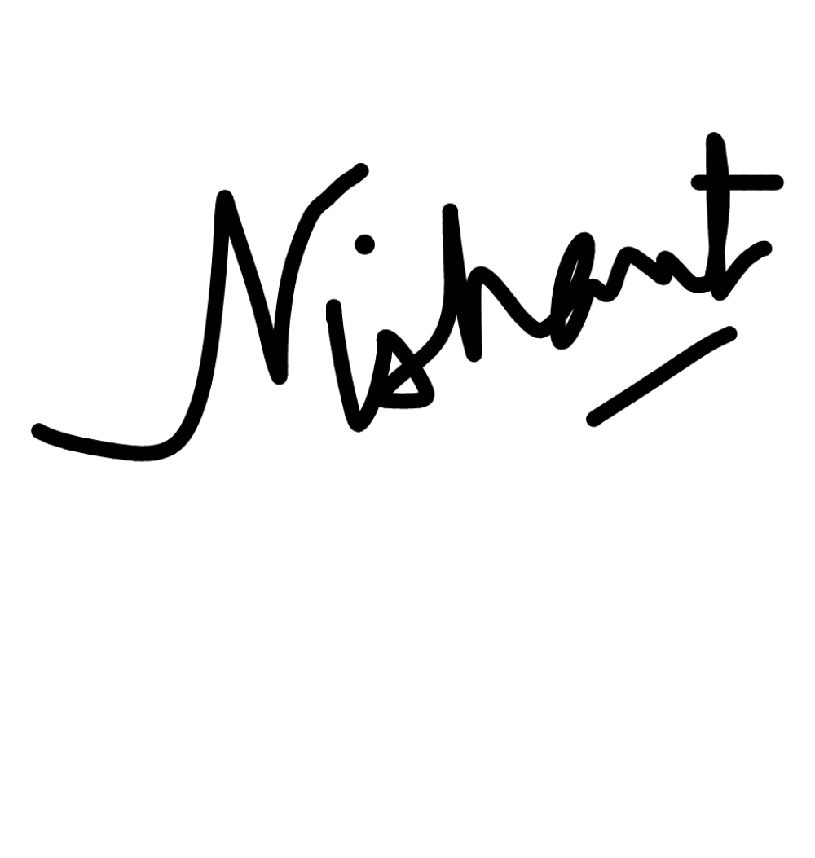



form part of the permanent records of the Receiving Party which it is bound by law or regulatory requirement to preserve, or which the Receiving Party may reasonably request to keep for archive purposes, and the provisions of this NDA shall, notwithstanding its termination, continue to apply to all such Confidential Information.

**7.Miscellaneous**   
 a.This NDA supersedes all prior agreements, written or oral, between the Disclosing Party and the Receiving Party relating to its subject matter. This NDA may not be modified, amended, transferred, or discharged, in whole or in part, except in writing signed by both parties   
 b.This NDA will be binding upon and inure to the benefit of the parties hereto and their respective heirs, successors, and assigns. This NDA shall be governed by the laws of the country, state or province indicated above without respect to conflicts of law/choice of law provisions, and to the extent permitted by law, the parties agree that any disputes arising from this NDA shall be subject to the exclusive jurisdiction of the courts of relevant jurisdiction sitting in such country, state, or province.

c. The provisions of this NDA are necessary for the protection of the business and goodwill of the Disclosing Party and are considered by the Receiving Party to be reasonable for such purpose. The Receiving Party agrees that any breach of this NDA will cause the Disclosing Party substantial and irreparable damages and, therefore, in the event of any such breach, in addition to other remedies which may be available, the Disclosing Party shall have the right to seek specific performance and other injunctive and/or equitable relief.

d.This NDA shall be effective from the date of this Agreement and shall terminate one (1) year from such date.

**SIGNED FOR AFFINE ANALYTICS PVT LTD**

_______________________________   
Rajesh Narayan   
Senior Vice President – Growth Markets & Partnerships   
Date:

**SIGNED FOR Neosoft Private Limited**

__________________________________   
Name: Nishant Rathi   
Title: Director   
Date: 12th April, 2023

**Affine Analytics Private Limited**

453, BBMP No. 351/453, 4th sector, HSR Layout, Bangalore, KA, IN – 560102. **Affine Confidential**

Tel: +91-80-6569-0996 | Web: affine.ai | Mail: info@affine.ai

CIN No: U74999KA2011PTC057118